**SRS**

**Of**

**File Tracking**

*******************************************************************************

**Client’s Name: Kamadgiri Software Solutions (P) Ltd.**

**Project Manager Name:-Er. S Mishra**

**Trainee’s Name: -………………………………** **Enrollment No: -____________________**

1. **Introduction: -**

Locating files is one of the greatest problems in universities nowadays. Time is wasted archiving or searching files, energy is wasted chasing misplaced files, deadlines are missed and sometimes files are lost. Seeing these problems, I decided to make a system for file tracking that will solve all of these problems in the best proper way.

File Tracking System is a web application that manages all the files movement from one desk/room to another one and helps them in managing the flow of files effectively and efficiently. All the files such as: reports, decisions, requests, reminders, and others can be processed and tracked by the system at any time.

The system helps in online tracking or location information and pendency monitoring more effectively by providing a plethora of information at a glance. It has extensive facilities for managing classification of all files. The system follows a procedure of file unique numbering and enables file management, file statusmonitoring, file movement tracking, etc. It also has a very powerful search form to locate a file and analyse the history of movement of that file.

1. ***Objective:-***

1. Solution for effective and efficient management of files
2. Easy File Tracking
3. Online fast and secure file management
4. Staff improvement
5. Organizational efficiency improvement
6. Paper cost reduce
7. Less energy used
8. Time spent reduce
9. Eliminates duplication of files
10. Reduces possibility of mistakes
    1. ***Name of Modules:-***

There are 14 modules in the system which can be sequentially listed as given below:-

|  |  |  |  |  |  |  |  |  |
| --- | --- | --- | --- | --- | --- | --- | --- | --- |
| |  |  | | --- | --- | | 1 | Employee Registration | | 2 | User Authentication and Login Management | | 3 | Compose Message | | 4 | Enquiry Management | |

|  |  |  |  |  |  |  |  |  |  |  |  |  |  |  |  |  |  |  |  |  |  |  |  |  |  |  |
| --- | --- | --- | --- | --- | --- | --- | --- | --- | --- | --- | --- | --- | --- | --- | --- | --- | --- | --- | --- | --- | --- | --- | --- | --- | --- | --- |
| |  |  | | --- | --- | | 5. | Update Profile | | 6. | Dynamic Folder management | | 7. | File management | | 8. | Manage User | | 7 | Email sender | | 8 | Category Management File and folder | | 9 | Error Topics Management | | 10 | Expert search | | 11 | Message Sender | | 12. | Access Management(Permissions management) | | 13. | Upload and Download Management | | 14. | Forward File | | 15. | Search and Modify Error Solutions | |

* 1. ***Architecture of File Tracking:***

**File Tracking Management**

**Admin Zone**

**User Zone**

**General Zone**

|  |  |  |
| --- | --- | --- |
|  |  |  |

1. **General Zone**

**Take a Tour**

**Registration**

|  |  |  |  |
| --- | --- | --- | --- |
|  |  |  |  |
|  |  |  |
|  |  |  |

|  |
| --- |
| **Home/Login** |
| **Us** |
|

1. **User Zone**

**Home (Dashboard)**

**Upload Files**

**Error Solutions**

**Search file**

**Search Solutions**

**My files**



**My solutions**



**Setting**

**My Profile**

**Logout**

**Change**

**Password**

|  |  |
| --- | --- |
|  |  |
|  |  |

**Admin Zone**

**Manage login**

**Send Message**

**Send Email**

**Search file**

**Manage Users**

**Admin Dashboard**

**Search Solutions**

**This pages will be in the user zone:**

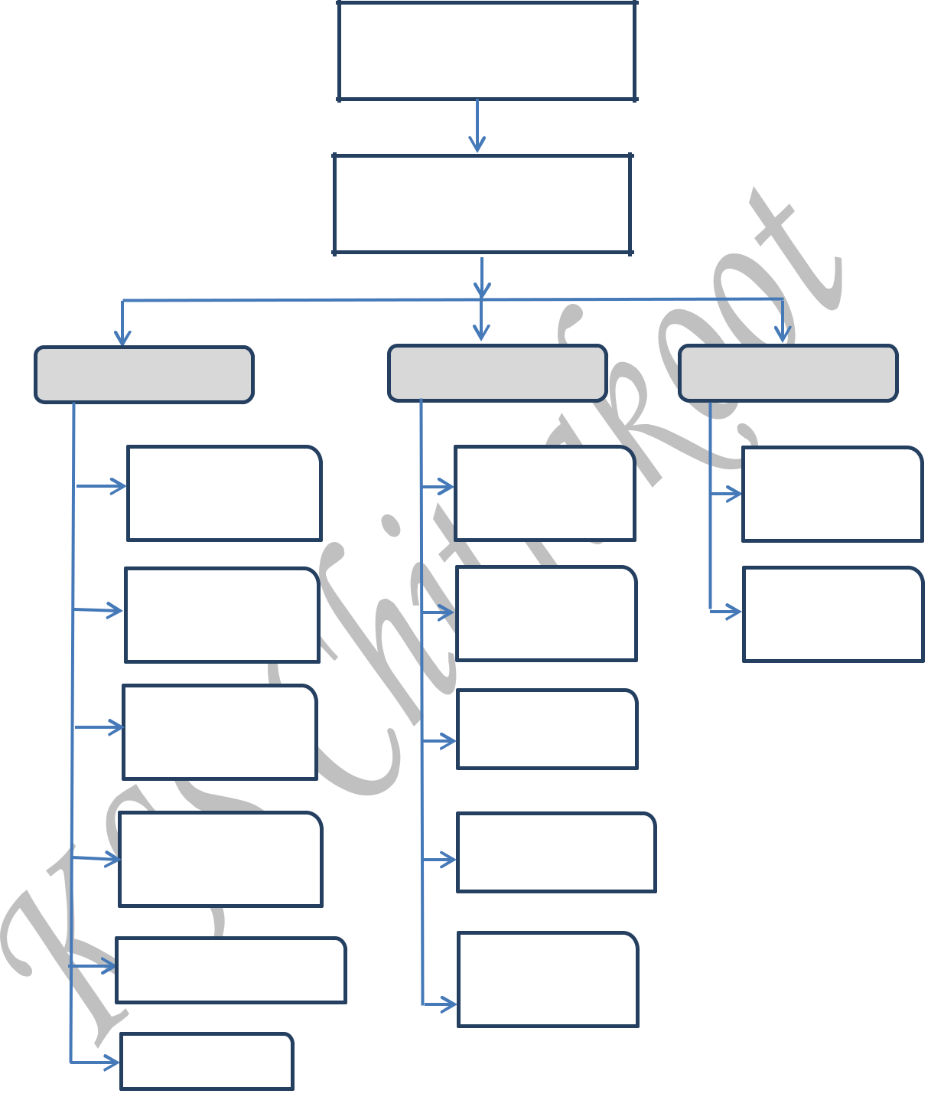

**Feedback**

**Change Password**

**Please send your valuable feedback**

Title/Topic of feedback

Old Password

New Password

Type your feedback

Here………

Re-enter your new password

**Send Feedback**

**Update**

**This pages will be in the login page of general zone:**

**Verify OTP**

**Forget Password**

Enter your registered email

Enter your registered email

Select user type

**Verify**

**Get OTP**

**This pages will be in the admin zone:**

**Compose Message**

**Change Password**

Email Id

Old Password

New Password

Type your message here……

Re-enter your new password

**Send**

**Update**

**Summary Of architecture:**



1. **General zone:**



**Home:** It should contain the name and logo of File Tracking, a unique initiative by KSS Chitrakoot. It also contains menu and a login Page and some information panel.

**Take a tour:** Take a tour page is content of all our website. You can visit here to know about our website and gather information that how to use our website and tools.

**Registration:** Register part includes a link for new registration. Registration is filled by the user before login. It includes following attributes:

Name, Gender, Email ID, Contact no, Profile Pic, password, confirm password, Captcha Code, Enter Captcha Code.

Email_Id is the primary key.

**Login:**­ This page is used by the user for login into the user zone. It contains following properties:

User id, password, forgot password, new user Sign Up here

1. **User Zone:**

**Home:**  This Page will work as a Dashboard.

**Upload Files:** You can upload any type of files like word file, excel file, pdf.

**Error Solutions:** you can send us your errors through message and also get solutions of errors.

**Search file:** you can search your uploaded file easily without time loss.

**Search Solution:** some solutions will be already exist in our portal. You can search and find the solutions.

**My files:** you can see your uploaded files.

**My Solutions:** You can upload your own query and also get the solution here on your personal email.

**Settings:** some modules of settings are mention below:-

**Update:** This page will used by user to update their profile.

**Feedback:** This page will used by User to submit a feedback.

**Change Password:** User can change their password. It contains the following attributes.

**Old Password, New password, Confirm New Password**

**3) Admin zone:**

**Home:** This page will work as a dashboard.

**Search Solutions:** Admin can search solutions of users’s query.

**Manage User:** This Page will used by admin to manage user’s accont.

**Search Files: Admin can search any type of user’s file**

**Manage Login: Admin can manage user’s login and also block their accounts.**

**Enquiry:** This Page will used by admin to manage Enquiry.

**Send SMS:** This Page will used by admin to Send SMS to Users.

**Send Email:** This Page will used by admin to Send Email to Users.

|  |  |  |  |
| --- | --- | --- | --- |
| **Table Name 1: EmployeeMaster** | | | |
| **COLUMN NAME** | **DATA TYPE** | **SIZE** | **REMARK** |
| Employee_id | Varchar | 70 | **Primary Key** |
| Name | Varchar | 70 |  |
| Gender | Varchar | 10 |  |
| EmailId | Varchar | 120 |  |
| Related_Designation_Id | Int |  |  |
| MobileNo | Varchar | 20 |  |
| Picture_File_Name | Varchar | 250 |  |
| DateTime_of_Reg | datetime |  |  |
| Is_Del | bit |  |  |

**Table Name 2: EmployeeDetails**

|  |  |  |  |
| --- | --- | --- | --- |
| **COLUMN NAME** | **DATA TYPE** | **SIZE** | **REMARK** |
| EmployeeDetails_Id | **Int** |  | **Pk(AI)** |
| Employee_Id | varchar |  | **FK** |
| AadharNo | Varchar | 20 |  |
| Related_City_Id | int | 100 |  |
| Related_Area_Id | int | 30 |  |

**Table Name:3 LoginManager**

|  |  |  |  |
| --- | --- | --- | --- |
| Column Name | Data Type | Size | Remark |
| UserId | Varchar | 70 | PK/FM |
| User_Password | Varchar | 250 |  |
| User_Type | Varchar | 20 |  |
| Login_Count | int |  |  |
| Last_Login_DT | datetime |  |  |
| IsBlocked/User_Status | bit |  |  |

|  |  |  |  |
| --- | --- | --- | --- |
| **Table Name : 4 FileUpload** | | | |
| **COLUMN NAME** | **DATA TYPE** | **SIZE** | **REMARK** |
| Employee Id | Varchar | 30 |  |
| File Title | Varchar | 30 |  |
| UploadedFile | Varchar | 100 |  |
| Description | Varchar | 300 |  |

**Table Name: 5 Error_Table**

|  |  |  |  |
| --- | --- | --- | --- |
| Column Name | Data Type | Size | Remark |
| Error topic | Varchar | 500 |  |
| Error Answer | Varchar | 2000 |  |

***6) Conclusion:-***

The goal of this web application is to improve file management, increase staff efficiency, save staff energy and time, reduce cost and improve the work efficiency by using the latest and fastest technologies. The one important thing that needs to be mentioned in this conclusion is that from the research I have done on file tracking systems, there is no file tracking system developed or implemented for universities at all. There are some file tracking systems used for some other purposes (ex: governmental purpose) implemented in few countries, however they are also some simple ones who tracks only receipts. Hence, I took this condition as a favours and hope that the project I am developing will have a massive usage worldwide in the near future.